The First Step
(You Must Be Born Again!)
Perhaps the phrase ‘You must be born-again’ is new to you? It is a typically Christian phrase. Let me explain.
Jesus, when talking to Nicodemus told him that he had to be born-again. Now, Nicodemus was a very religious man. So much so that he was a major leader in both the Jewish Government and Church.

Yet, he had no idea of what Jesus was talking about! So, you can be very religious and not be a Christian.

What Jesus was talking about is a new birth or rebirth experience where a person gets an opportunity to begin all over again. Paul wrote that if any man be in Christ, he is a new creation, all things have been made new.

Now, you may ask, why should we want to be born-again?

Because to be in God’s presence is desirable because in His presence is fullness of joy and peace. But, nothing unclean or sinful, (which we are), can enter His presence.

So, you and I have a problem. We have good reason to want to be close to God. But, God’s Holiness and Righteousness prevents Him from allowing us in His Presence.

The Prophet Isaiah said that all our righteousness is as filthy rags. The Bible also says that the soul that sins shall die.
Paul in his letter to the Romans states that 'All have sinned and fallen short of the glory of God.'

The prophet Isaiah also said, 'All we like sheep have gone astray'... King David continues the thought with 'there is none righteous no not one.'

Paul stated that by the works of the law shall no flesh be justified.

And, further, without the shedding of blood there is no remission of sin.

Of course there are those that feel that if they can do enough good works they will win God’s approval and be allowed into His Presence.

But, Paul wrote in his letter to the Ephesians that God’s approval, forgiveness, and acceptance is a gift of God through Faith, not something we can do but purely by God’s grace.

Jesus Himself stated that at the judgment, there would be those that would say that they had done this or that great work, and He would reply depart from me, I never knew you.

All of us are guilty! And, subject to God's Eternal Death Penalty, which is eternal separation from God in a lake of fire, (Prepared, not for us, but for the devil and his angels). If in His presence there is fullness of joy how much sorrow, and pain must there be when absent from Him?
So, it is impossible for man to make himself acceptable to God. Yet, we were created to have fellowship with God.

And, all the neat toys in the world will not fill the void of a life without Jesus.

Paul cried out in Romans, ‘O wretched man that I am who shall deliver me from this body of death?’

But, God had already set a plan in motion to meet man’s need of a savior.

God in His perfect timing sent Jesus about who was said: "In the beginning was the Word and the Word was with God, and the Word was God. And the Word became flesh and dwelt among us, and, we beheld His glory as the only begotten son of God.

So, what was not possible in human strength, God, made possible through Jesus Christ.

The Old Testament law of Moses was a temporary covenant God made with man until it was time for Jesus to be revealed.

This law was imperfect in that forgiveness for sins was temporary because the blood of bulls and goats being imperfect decayed and had to be replaced year by year.

However, Jesus who knew no sin, and thus had perfect and untainted blood was able to offer Himself up as a sacrifice in our place, and now His blood is a perfect and eternal reminder to God that our sins have been paid for in full,

However, legally, the 'account' that contains the righteousness of Christ must be acknowledged and received before it can be applied to one's life.

You may ask, "Jesus Christ?”, aren't there any other ways to be acceptable to God?"

No, Jesus himself said; "I am the Way, the Truth, and the Life, no man comes to the Father but by me."

Luke wrote in Acts that there is no other Name under heaven whereby men must be saved except Jesus Christ.

Paul, the apostle, wrote that there can be no other foundation laid except for Jesus Christ.

So, to be Born-Again you must accept the testimony about who Jesus Christ says he was, and is, and make a decision to become Born-Again.

This is done by faith. Paul wrote that: "the word of faith is right next to you, even on the tip of your tongue, that is if you will publicly acknowledge Jesus Christ as Lord, and believe in your heart that God raised Him from the dead... you shall be saved." Romans 10:9-10 para.

Becoming a Christian is that simple:
- Agree with God, and admit that you are a sinner.
- Believe that Jesus was who He said He was.
- That He died for your sins.
- That God raised Him from the dead.
- Make Him Lord, (undisputed ruling authority), of your life.
- Publicly acknowledge your decision to do so, confess Him.

To begin, use this simple prayer as an example of how to start talking one on one with God:

Father God, I admit that I am a sinner with no hope of ever living up to your expectations, that I am deserving of punishment. Father, I thank you for sending your Son Jesus to die in my place, so that I won’t have to pay for my sins myself. I accept your free gift of forgiveness from my sins, and with your help promise to live a life worthy of the sacrifice Jesus voluntarily made for me. I promise to tell others that I have made this commitment to you. Amen.

That's it! That's all there is to becoming a real born again believer in Jesus Christ.

If you have made a decision to follow Jesus please write or call us.

We would love to hear from you and help you become a strong Christian by sending you additional information.

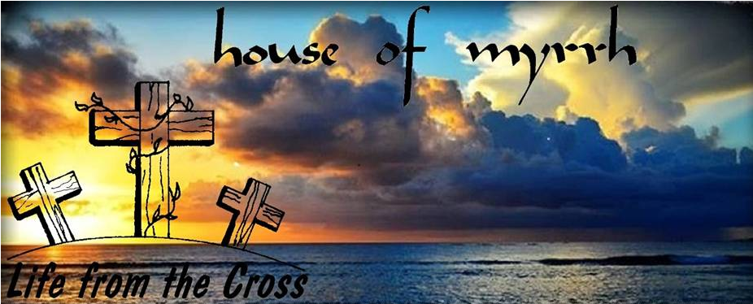
www.houseofmyrrh.org

The First Step

(You Must Be Born Again!)

